Capter 5

Overview
Multi-Player mode allows you to fly Battle of Britain missions with up to seven other flyers over the Internet or a network, and with another player over a direct serial or modem link. In multi-play you can play Death Match,
Team Play or several Quick cooperative or adversarial missions. You can select any of the available aircraft that are flyable in the single player mode, although you cannot take the role of a gunner. The dynamic campaign is NOT a multi-player
option.

PRELIMINARY NOTES
Some things to remember for all multi-player games are as follows:

- It is a good practice to reboot your computer prior to playing online especially if you have been on the Internet or running other programs for an extended period of time. Web browsers often keep your online history stored in memory, which sometimes can reduce your available RAM to play the game.
- Remove any programs from memory running under windows that aren't absolutely essential to running your system (e.g. ICQ, Real Player etc).
- When using any third party voice communications program (e.g. Roger Wilco, Battlecom, and Teamstream) try not to activate voice communication when a player is trying to join or when you are waiting to enter a mission.

STARTING UP MULTI-PLAY
Choose the Multi-Player option on the Main Menu. The first Multi-Play screen asks you to select your multi-play service. At this point you must select a connection type:

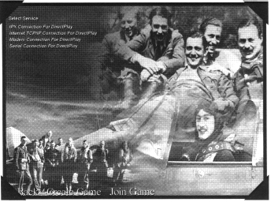
- IPX Connection for Direct Play
You must have an IPX/SPXcompatible protocol loaded under Windows 95/98 (it comes with Windows 95/98). To identify if you have this loaded select the "START" menu on the Windows desktop and choose SETTINGS followed by CONTROL PANEL. Then select the NETWORK icon.
Scroll down in the box to see if any kind of IPX/SPX-compatible protocol is listed.

- Internet TCP/IP Connection for Direct Play
An Internet service provider (ISP) or LAN with TCP/IP protocol is required. Two to eight players can play over the Internet (bandwidth permitting). All players should exchange IP addresses in case you want to take turns being the host. Each player wanting to join an Internet TCP/IP connection needs to know the host's IP address.
Typically players will meet in some sort of chat zone on the Internet and exchange IP addresses prior to connecting. Determine who has the fastest connection speed and computer and that person should make the best host. It is important to remember to completely exit your chat environment and all other unnecessary software prior to loading the game.

By far the most common problem in getting a connection on the Internet is incorrectly copying the IP address. Make sure you double check with your partner prior to trying to connect.

To identify your own IP address run the WINIPCFG.EXE located in your Windows subdirectory (i.e. c:\windows\WINIPCFG.EXE) while connected to your Internet Service Provider (ISP). If you do not have a permanent IP address you will need to find out your IP address every time you reconnect to your Internet Service Provider. Make sure whoever you're playing with understands this as well. If you are playing over a LAN (Local Area Network), then you won't need to know the IP address of the host computer - games can be detected and listed automatically.

- Modem Connection for Direct Play
A maximum of two players can connect via a 28,800-baud modem (or faster). Make sure both players' modems are configured correctly and set at the highest speed for their connection. Prior to connecting both players need to agree which computer will serve as the "Connect" computer and which will "Answer" on the connection. The player with the faster computer would be best suited for the host (Answer) computer.

Both players should be aware of which Comm Port their modem is attached to and should know the fastest baud rate of their modems. It is also a good idea to have each other's phone number at hand. If you have any problems, you can access the Windows 95/98 (Modem) Properties by clicking CONFIGURE on the Modem screen. If your modem is not configured correctly, please consult your modem and Windows 95/98 documentation (make sure you don't have multiple modem drivers loaded). If you've made any changes to your settings, restart Windows before trying to connect. This ensures the changes are saved.

- Serial (NULL MODEM) Connection for Direct Play
A maximum of two players can connect via a Null Modem cable (not to be confused with a serial cable) to active serial ports of each computer. In some cases you may have to install software or drivers to use your null modem cable. Consult your computer's documentation for more information.

You need to know what serial (COM) port that your null modem is connected to with both computers. Many computers have labels (i.e. 1=COM1, 2=COM2) or you can refer to the documentation that came with your computer which may have diagrams with the communication ports labeled.

If you can't connect check for the following:
- Port conflicts - use the Windows Device Manager to view devices by connection. Make sure only one device is listed next to the COM port you connected the cable to. Device Manager can be found via the "START" icon on your desktop. Look under "SETTINGS" then "CONTROL PANEL followed by the "SYSTEM" icon. Check with your system manufacturer for help with port conflicts.
- You can also try selecting another COM port and/or a lower baud rate.
Once you have chosen a suitable connection you have two options at the bottom of the screen - Create Game and Join Game.

CREATE GAME
The Create Game selection is found at the bottom of the first Multi-Play screen. You can create a game either by highlighting a service and clicking on this button, or double clicking on a service. Creating a game is synonymous with being the host. Once you select Create Game the game selection screen will appear. This allows you to configure the type of game that you want and to set session parameters.
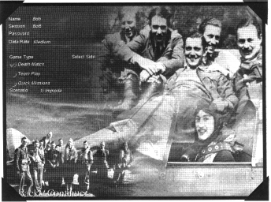
The various parameters are:
- Player name
This allows you to enter the name you wish to be known as in the game. It is particularly important to use this if there are going to be more than two players.

- Session name
This is the name that will appear to the other players trying to join your game.

- Password
This allows you to set a password to allow for private games or those that you allow in via the Visitors' Book (see below).
- Data Rate
This affects the amount of data that is transmitted and received. It will initially be set to a level that is suitable for the service provider that has been chosen. If difficulties arise in creating and playing games then try a lower data rate. High data rates can be used if you have good connections to other players. Ultimately you will want to use the highest data rate level that you can reliably play the game at. Some trial and error may be needed to find the right data rate for your connection.
Data rate does NOT affect 3d-frame rate. However, higher data rates lead to a more accurate simulation.

- Select side
In Team Play and Quick missions you can select whether you want to play RAF or Luftwaffe aircraft. You will be limited to that side's aircraft for the game. In Death Match all flyable aircraft are available to be chosen.

- Game Type
This determines the type of missions that can be played. Death Match and Team Play games involved only human controlled aircraft.

Several different starting positions are available:

DEATH MATCH SCENARIOS

Implode: Players are headed directly into the centre of a circle of players.

Pairs: Players start out side-by-side heading in the same direction.

Wheel: Players are heading around in a circle.

Same altitudes: Players are going head-on at the same altitudes.

Different altitudes: Players are going head-on at different altitudes.

Explode: Players are heading directly away from a circle of players.

Implode/ Explode: Implode and Explode are selected at random.

Flyby: Players start side-by-side heading in opposite directions.

TEAM PLAY SCENARIOS

Flights no advantage: Opposing flights heading towards each other.

Flights Luftwaffe advantage: Luftwaffe aircraft start behind RAF aircraft.

Flights RAF advantage: RAF aircraft start behind Luftwaffe aircraft.

Flights, random advantage: Advantage of RAF or Luftwaffe selected at random.

Elements scattered: Groups of two players start outtogether, but scattered from other two player elements.

Elements close: Groups of two players start out together, but close to the other two player elements.

Singles Implode: Players are heading directly in the middle of the circle of players.

Singles Explode: Players are heading directly away from the circle of players.

QUICK MISSIONS
Allows you to play with other players and Al aircraft in fifteen of the quick shot missions available in the game. You can play cooperatively or head to head with players and AI aircraft from both sides. Choose any of the available missions on the quick missions screen and select Ready Room to continue.

JOIN GAME
The Join Game selection at the bottom of the service provider selection screen allows you to join a game created by another host. What happens depends to some extent on your connection type:
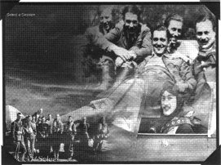
- IPX connection (see also "Selecting a connection type" above)
There is no extra information required for an IPX LAN connection. Two to eight players can "join" a game. A list of network games available will appear. Select the one you wish to join by clicking on it and then clicking select. You will then be taken to the game selection screen. If no names appear under the session list, then no games are available.

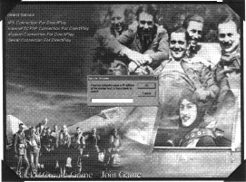
- TCP/IP Connection (see also "Selecting a connect^{i}on type" above)

A windows dialogue box will appear asking you for the name or IP address of the computer that is hosting the game. Enter the address and click on OK. If you are on a LAN, leaving the address blank will search the network for available games. Once your computer has connected to the host a list of games will appear. Select the one you wish by clicking on the name and then clicking select. You will then be taken to the game selection screen.

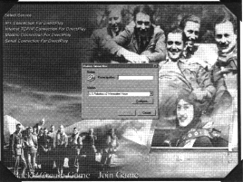

- Modem Connection (see also "Selecting a (connection type" above)

A windows dialogue box will appear allowing you to configure your modem and provide the telephone number of the computer you wish to connect to. Once you are satisfied with your modem configuration and have entered the phone number click on Connect. The game will then attempt to connect you to the host computer and if successful you will be taken to the game selection screen.

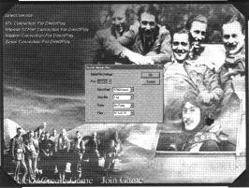

- Serial Connection (see also "Selecting a connection type" above)

After selecting "Serial Connection For Direct Play" a windows dialogue box will appear allowing you to configure your serial connections.
Your port settings, apart from Port, must correspond with the host's settings for the game to connect. Once
you are satisfied click on OK. The game will then attempt to connect you to the host computer and if successful you will be taken to the game selection screen.

GAME SELECTION SCREEN

Once you have connected to the host computer you will be taken to the game selection screen. This allows you to view the game setup that the host selected. You can also enter your name and, if the game is Team Play or Quick Mission, select the side you wish to play on. If the game has a password that you don't know, you can request entry by clicking on the button to add your name to the host's Visitor's Book. If the host decides you can join then you will be able to join after a short period of time.

READY ROOM

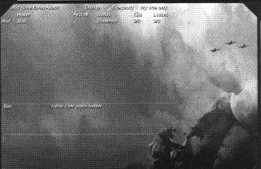
If you have selected either Death Match or Team Play and are ready to join the game click on continue and you will be taken to the Ready Room Screen.

Whether you have created or joined a game, you will eventually end up in the Ready Room. The Ready Room Screen displays players currently in the game, along with aircraft chosen and their score. It also allows you to chat to other players.

In Team Play and Quick Missions, RAF players are listed first, followed by Luftwaffe players. The players' names are followed by the aircraft they have chosen, the game screen they are currently in and their score.

To chat to other players type your message in the box and press Return. In Team Play or Quick Mission games you can choose to chat either to your side only or to all players by clicking on the appropriate tick box at the top of the screen. To chat to an individual player, click on his name. The name will highlight and your messages will be sent only to that player until you click on another name or choose everybody on your side only.

There are a number of options at the bottom of the Ready Room screen, and some of them are only available in certain circumstances,
for instance when you are a game host:

- Quit
Quit the game and return to the main user interface screen.
- Fly
In Death Match and Team Play games when everyone is ready the host can click on Fly and the game will begin. If a player joins the game while the other players are flying then he will be able to click on Fly to join in.

- Frag

In Quick Shot mission games, clicking on Frag will take the player to the Frag screen. Here you will be able to choose which aircraft position you wish to fly. Chat facilities are available as in the Ready Room screen, but messages will be sent to all players. To choose an aircraft to fly, click on the pilot name. You
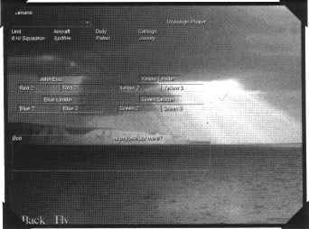
cannot choose an aircraft that has already been chosen by another player. To unassign yourself from an aircraft click on another aircraft or click on the unassign tick at the top right of the page. When all players have chosen their aircraft the host can click on Fly and the game will begin. A player may join a game after it has begun, while other players are flying. Simply choose an aircraft in the Frag screen and select Fly to join in. Aircraft that have been killed will be labelled as 'KIA' and cannot be selected to fly in.

- Visitors
A new player wanting to join the
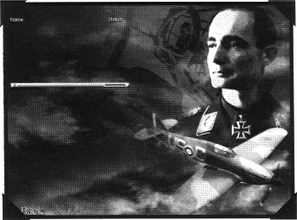
game, but who doesn't know the password, should click on "Add my name". A message will appear in the host's chat window indicating this request. The host should first click on the Visitors Book and then on the Status of the player - which will be
Excluded. The status will change to Accepted. The new player is now able to join the game. The new player should be patient as the host may be flying a mission and may not be back in the Ready Room for some time.

- Set Up
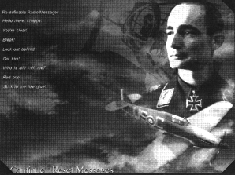
There is no chat available while you are flying a mission, however you can set up customized pre-set radio messages. Players can edit radio messages that they wish to send to other players while flying a mission. To edit the radio messages click on Setup. The Setup screen allows you to edit the messages or to reset to the default messages if you wish. To edit a message click on it and type in the new message. Setup will be saved when you leave the game and kept for future games. Later on in this chapter we will discuss how to use the messages when flying a mission (Check under 'Multi-play In Flight Options' below).

Setup also allows a player to choose their aircraft in deathmatch or teamplay games. In teamplay games, the player is limited to aircraft of their own side i.e. Spitfire and Hurricane for RAF; ME109, ME110 and JU87 for Luftwaffe. In Deathmatch games players can choose any aircraft.

- Edit Mission
In Quick Mission games the host can alter the mission setup by selecting Edit Mission. For instance, the scenario or the time of day can be changed. Once you are satisfied with the mission click on Ready Room to return. If the host edits the mission then when he returns to the Ready Room any players in the Frag screen will be returned to the Ready Room and must reselect an aircraft to fly. Guests can click on Brief to view the details of the current mission if the game is a quick mission.

- Config
Players have access to the PC and Sim Config screens. However, only the host controls the options that affect game difficulty.

MULTI-PLAY IN FLIGHT OPTIONS

Once you have selected Frag or Fly, once a mission has commenced there are several options unique to multi-play:

- Radio Messages
Under the Radio Communications menu (press R when in the cockpit) there is an option to send pre-set radio messages to other players in the game (see Messages above). Comms Msg Recipient and Comms Message are two additional options. Comms Msg Recipient allows you to select whether to send messages to all players or only to members of your team. The default selection is to all. The selection will stay the same until it is changed or a new game begins. Comms Message will display a list of your pre set messages. Selecting the numbered message from the list will send that message to everybody on your team depending on the Comms Msg Recipient.

- Resurrection in Multi-Play
If a player is killed then he can wait until his aircraft resurrects on its own or he can press S to force a resurrection to take place. This is not available immediately; the player must wait for a few seconds before being able to resurrect. The S key is only available in Death Match and The Team Play games.

When a player dies in Death Match or Team Play games he will be resurrected and his aircraft will start to spiral upwards in autopilot mode. To retake control of the aircraft press J. If you do not press J, control will automatically handed over at 10,000 feet or 2,000 feet above the highest aircraft.

In Quick Mission Games a player who has died can exit the game and go to the Frag screen to choose an AI aircraft to take over. If there are no more available aircraft then the player will have to wait at the Ready Room for the game to end.

ENDING A MULTI-PLAY GAME

If the host chooses to end the game then all players will be taken to either the Debrief screen for Quick Missions or to the Ready Room screen.

If a player dies in a Quick Mission game then he will be taken to the Ready Room screen. Here he can go to the Frag screen and select an available aircraft and rejoin the game in that aircraft, taking over the seat from the Al pilot.

Players who exit the game can rejoin as long as the host keeps the game running.

MULTI-PLAY DEBRIEF

In Death Match and Team play there is no Debrief. The scores of each player will be displayed in the Ready Room.

For Quick Missions the Debrief will show all items destroyed. Players can then go to the Ready Room screen for another game.

